|  |  |  |  |
| --- | --- | --- | --- |
|  | Bansilal Ramnath Agarwal Charitable Trust's  Vishwakarma Institute of Information Technology  **Department of**  **Artificial Intelligence and Data Science** | | |
| Name: Siddhesh Dilip Khairnar | | | |
| Class: SY | Division: B | | Roll No: 272028 |
| Semester: IV | | Academic Year: 2022-2023 | |
| Subject Name & Code: Advanced Data Structure, ADUA22202 | | | |
| Title of Assignment: Write a program to implement binary search trees and perform operations. | | | |

Aim:

Write a program to implement binary search tree and perform following.

operations:

a. Insert

b. Delete

c. Mirror image

d. Display level wise

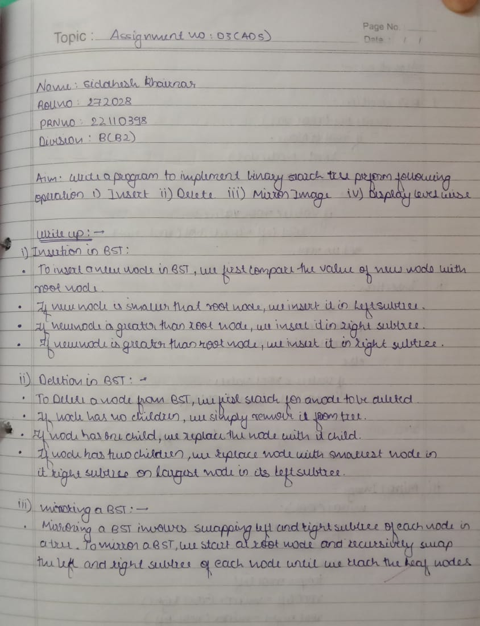

Experiment:

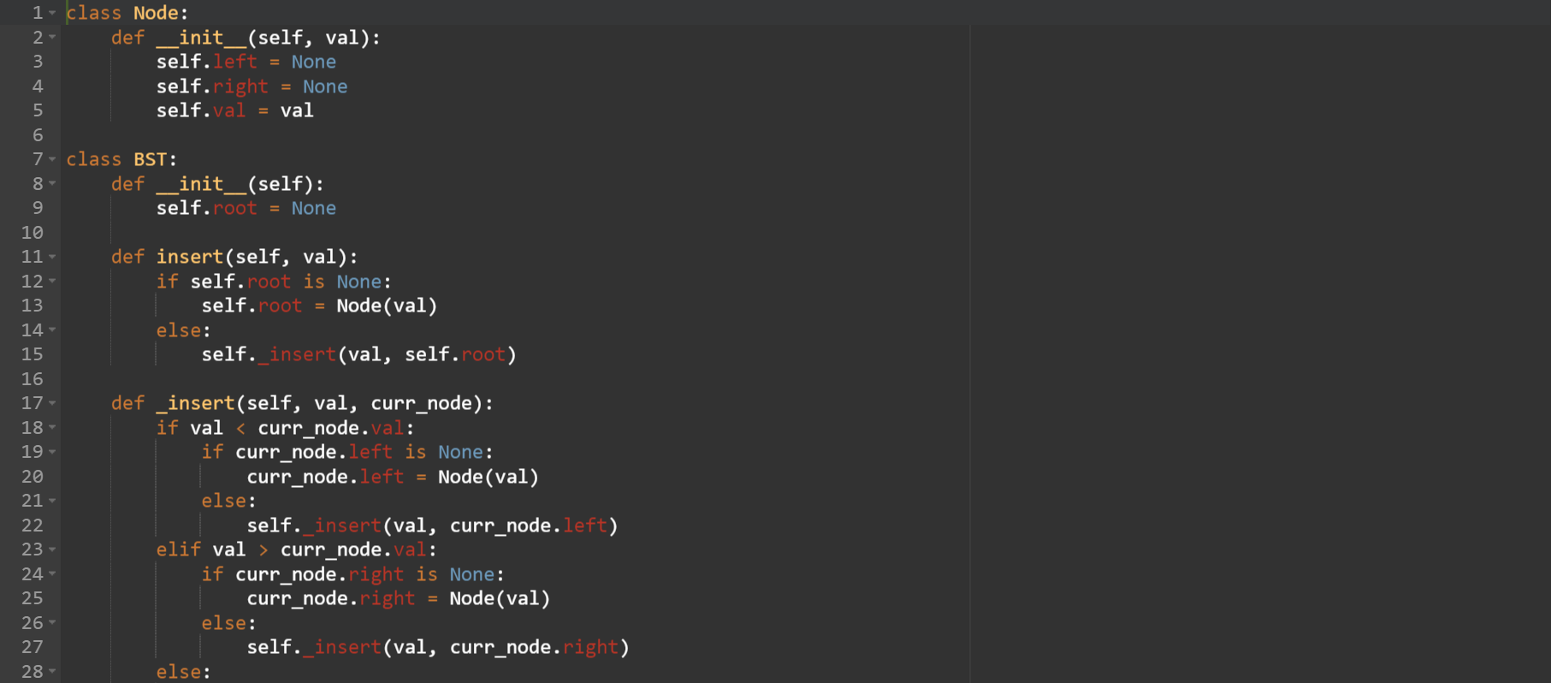

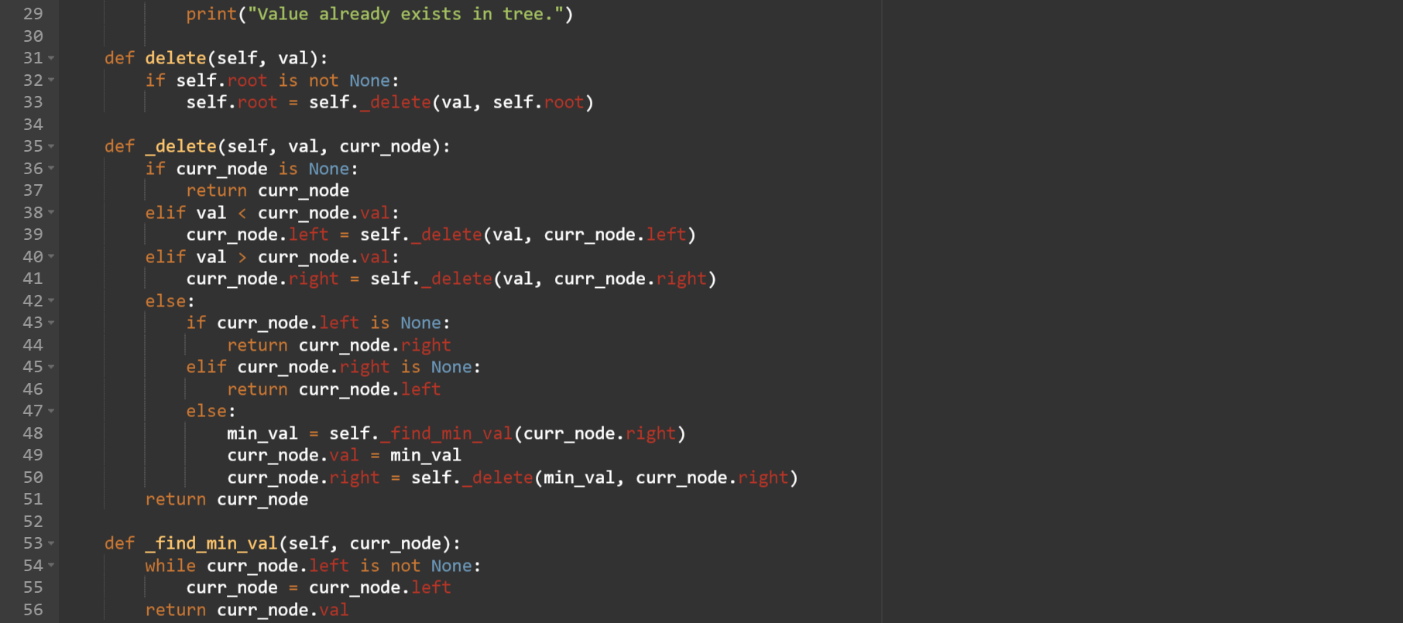

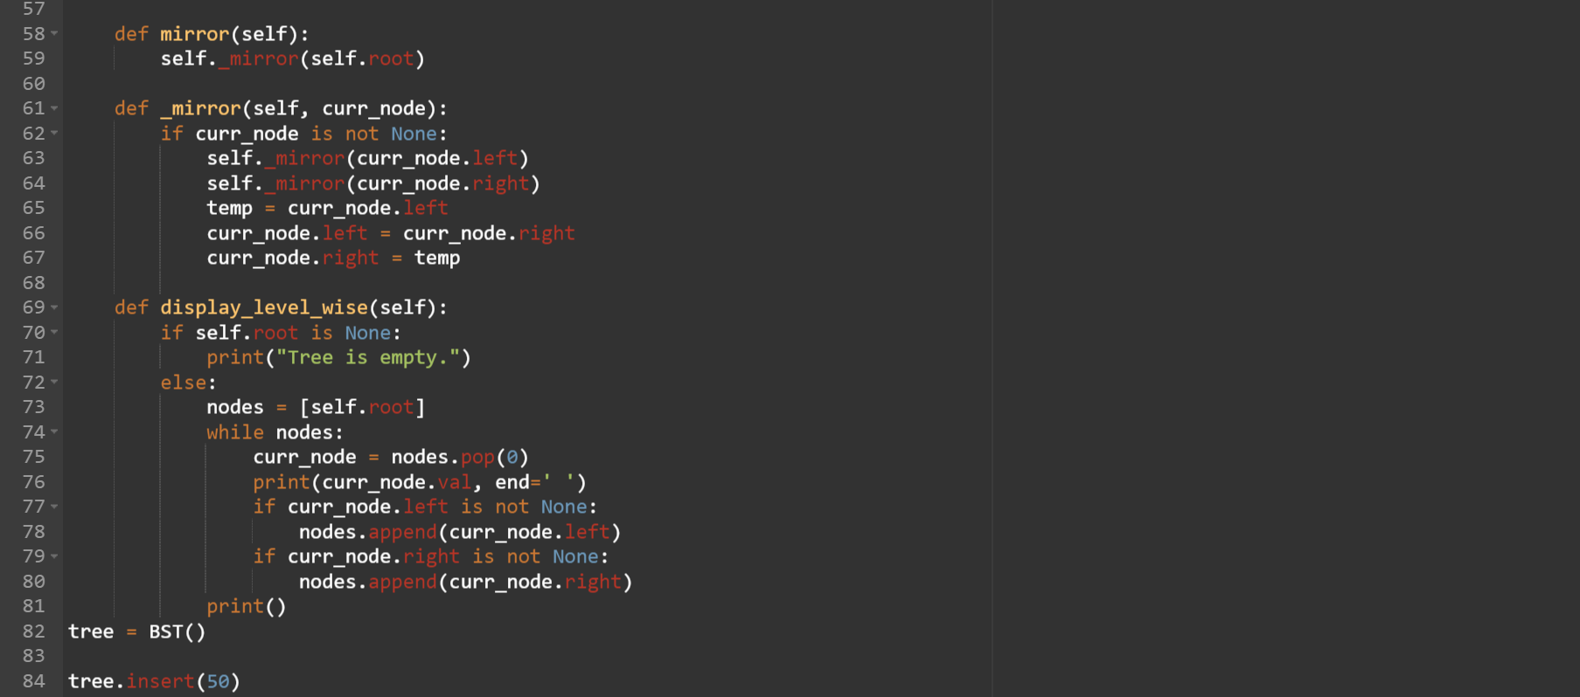

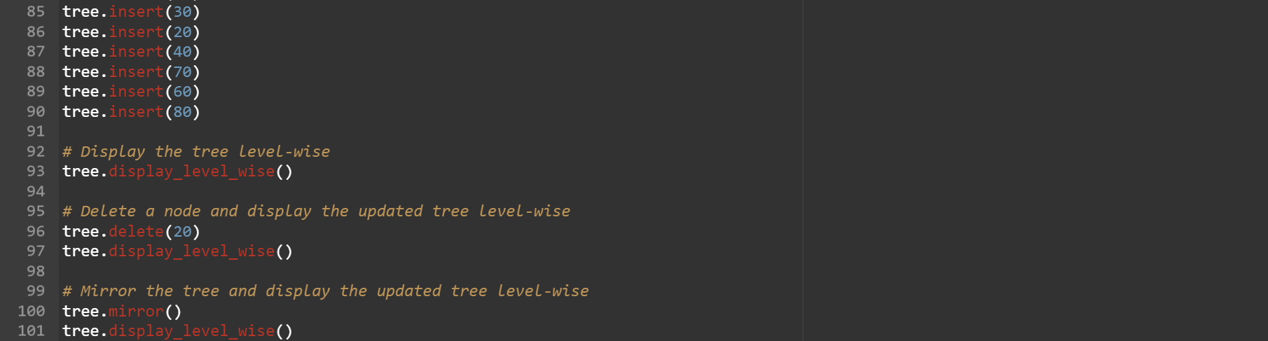

Output:  
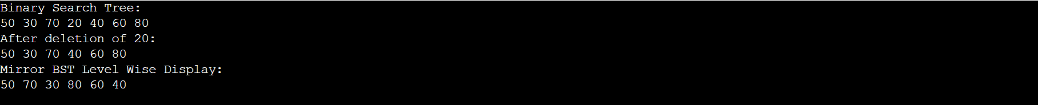

Conclusion: Thus, I’ve successfully completed and performed binary Search Tree operations. I’ve successfully inserted, deleted, and displayed level wise BST.